

|  |  |  |  |  |  |
| --- | --- | --- | --- | --- | --- |
| Programme | : | **B.Tech CSE** | Semester | : | **Fall 2017** |
| Course | : | **Internet and Web Programming** | Code | : | **CSE3002** |
| Faculty | : | **Prof. Rajiv Vincent**  **Prof. Rajesh** | Slot | : | **L7+L8** |

**HTML EXERCISES**

1. BASIC EXERCISES

1. Create a webpage that prints your name to the screen.
2. Create a webpage that prints the numbers 1 - 10 to the screen.
3. Create a webpage and set its title to "This is a webpage".
4. Create a webpage that prints the message "When was this webpage created? Check page's title for the answer." to the screen, and set the title of the page to the current date.
5. Create a webpage that prints any text of your choice to the screen; do not include a head section in the code.
6. Create a webpage which keeps track of the browsers information and do the following
   * refreshes its page in 5 seconds,
   * expires in a duration of time

2. HTMLTEXT EXERCISES

1. Print your name in green
2. Print the numbers 1 - 10, each number being a different color.
3. Prints your name in a Tahoma font.
4. Display a part of a word with bold underline.
5. Print a paragraph with 4 - 5 sentences. Each sentence should be a different font
6. Print a paragraph that is a description of a book; include the title of the book as well as its author. Names and titles should be underlined, adjectives should be italicized and bolded.
7. Print your name to the screen with every letter being a different heading size.
8. Write a comment line on your code and make sure it is not displayed in the page
9. Print a2+b2=2ab
10. Print H2O
11. Display a c code as it is in the page
12. Set the background color of the page as yellow
13. Set an image as background of the page
14. Set the font size as 10. Print it. Again try to decrease the font size. Check whether the font size is reduced.
15. Apply marquee for your name
16. Display a paragraph contents in a single line.
17. Display 2 paragraph contents using div.

3. HTML TEXT FORMATTING, LISTS EXERCISES

1. Print the squares of the numbers 1 - 20. Each number should be on a separate line, next to it the number 2 superscripted, an equal sign and the result.
2. Prints 10 names with a line break between each name. The list should be alphabetized, and to do this place a subscripted number next to each name based on where it will go in the alphabetized list. (Example: Alan1). Print first, the unalphabetized list with a subscript number next to each name, then the alphabetized list. Both lists should have an <h1> level heading.
3. Print two lists with any information you want. One list should be an ordered list, the other list should be an unordered list
4. Print a list which starts with 7 with the type i
5. Prints an h1 level heading followed by a horizontal line whose width is 100%. Below the horizontal line print a paragraph relating to the text in the heading.
6. Print a definition list with 5 items
7. Print two addresses in the same format used on the front of envelopes (senders address in top left corner, receivers address in the center)
8. Print ten acronyms and abbreviations of your choosing, each separated by two lines. Specify the data that the abbreviations and acronyms represent

4. HTML IMAGE EXERXISES

1. Display five different images. Skip two lines between each image. Each image should have a title.
2. Display an image that has a border of size 2, a width of 200, and a height of 200.
3. Display the image towards the right corner of the webpage

5. TABLES

Display the following tables with at least 3 rows

i.Apply table border and apply border color

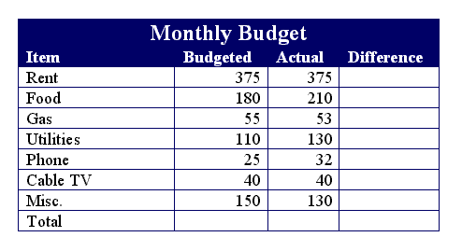

ii.Apply Cell Padding

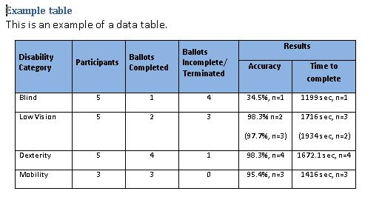

iii. Apply Cell Spacing

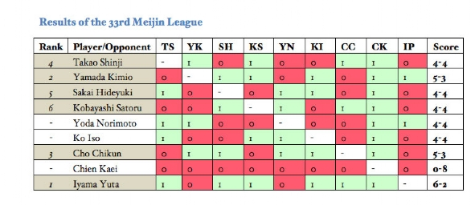

iv. Apply cell rules for outer layer alone and set height and width for the table

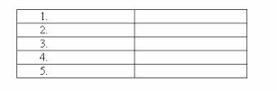

v. Display the table towards the right of the web page

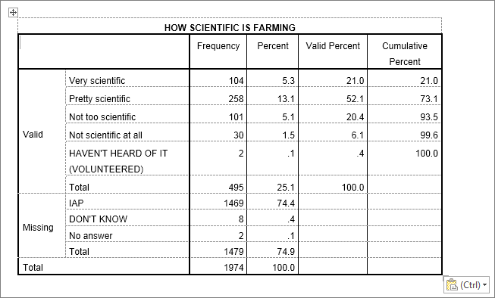

vi. Apply caption

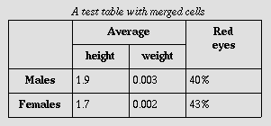

6. Forms

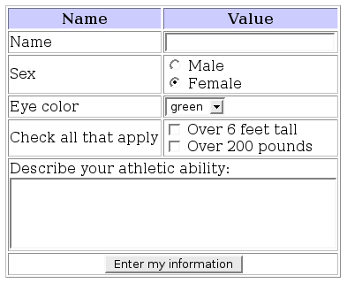

7. Forms with Tables

